**DSG Lecture 1: ML-0 Assignment**

[Implement linear regression](https://www.geeksforgeeks.org/linear-regression-python-implementation/)

Q1. Explain the bottom questions answer in detail

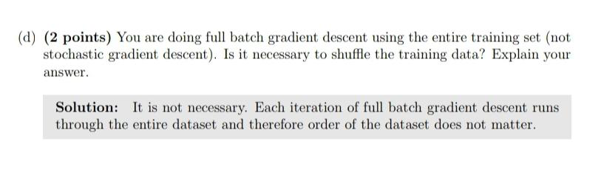

Q2. Implement basic Gradient Descent in a jupyter notebook.

Also explain in the same file how each hyperparameters tuning changes the outcome?

Q3. Go through first 2 chapters of ISLR in detail, especially Bias Variance tradeoff.